**# **System Design Document: Real-Time Chat Application using MERN Stack\*\***

## **Table of Contents**

1. **1. Overview**

2. **2. Key Dependencies**

3. **3. Architecture**

- 3.1. System Architecture Diagram

- 3.2. Technology Stack

4. **4. Components and Workflows**

- 4.1. Authentication Workflow

- 4.2. Chat Workflow

- 4.3. Profile Management Workflow

5. **5. Database Schema**

- 5.1. User Collection

- 5.2. Chat Collection

6. **6. API Design**

- 6.1. Authentication APIs

- 6.2. Chat APIs

- 6.3. User Profile APIs

7. **7. Real-Time Communication**

- 7.1. Event Flow Diagram

8. **8. Security Considerations**

9. **9. Scalability and Performance**

10. **10. User Interface Design**

- 10.1. UI Components

- 10.2. UI Flow Diagram

11. **11. Conclusion**

---

**## **1. Overview\*\***

The **BuzzLine Application** is designed to facilitate seamless communication between users in real-time. Built using the **MERN (MongoDB, Express.js, React.js, Node.js)** stack, the application leverages **Socket.io** for real-time interactions, **JWT (JSON Web Tokens)** for secure authentication, and **Chakra UI** for a responsive and modern user interface. The application allows users to register, authenticate, join chat rooms, send and receive messages instantly, and manage their profiles.

**## **2. Key Dependencies\*\***

**### **Frontend Dependencies:\*\***

- **React (`^17.0.2`)**: JavaScript library for building user interfaces.

- **@chakra-ui/react (`^1.6.2`)**: UI component library for React.

- **@chakra-ui/icons (`^1.0.13`)**: Icon library for Chakra UI.

- **@emotion/react (`^11`) & @emotion/styled (`^11`)**: CSS-in-JS libraries for styling.

- **react-router-dom (`^5.2.0`)**: Routing library for React applications.

- **axios (`^0.21.1`)**: Promise-based HTTP client for making API requests.

- **socket.io-client (`^4.1.2`)**: Client-side library for Socket.io.

- **Other Libraries**:

- `bcryptjs`: For password hashing.

- `jsonwebtoken`: For JWT-based authentication.

- `colors`, `dotenv`, `express-async-handler`, `mongoose`, `nodemon`, `openai`, `socket.io`: Backend dependencies.

**### **Backend Dependencies:\*\***

- **Node.js (`^14.x`)**: JavaScript runtime environment.

- **Express.js (`^4.17.1`)**: Web framework for Node.js.

- **Mongoose (`^5.12.9`)**: ODM for MongoDB.

- **Socket.io (`^4.1.2`)**: Enables real-time, bidirectional communication.

- **bcryptjs (`^2.4.3`)**: Library for hashing passwords.

- **jsonwebtoken (`^8.5.1`)**: For generating and verifying JWTs.

- **dotenv (`^9.0.2`)**: Loads environment variables from `.env` file.

- **express-async-handler (`^1.1.4`)**: Middleware to handle exceptions inside async express routes.

- **nodemon (`^2.0.22`)**: Utility that monitors for any changes in your source and automatically restarts your server.

---

**## **3. Architecture\*\***

**### **3.1. System Architecture Diagram\*\***

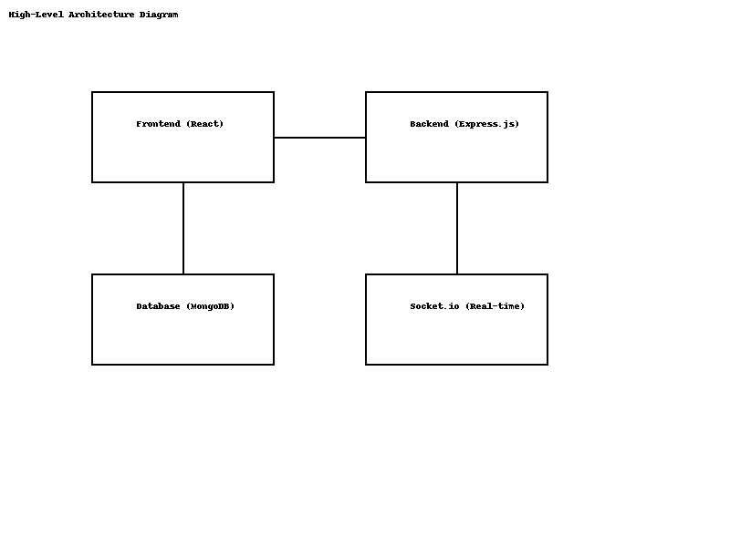

**Description of the Diagram:**

1. **Frontend (React JS):**

- Interacts with users through UI components.

- Sends HTTP requests to the backend for authentication and data retrieval.

- Establishes a WebSocket connection using Socket.io for real-time messaging.

2. **Backend (Node.js & Express.js):**

- Handles HTTP requests for authentication, user management, and chat functionalities.

- Manages Socket.io connections for real-time communication.

- Interfaces with MongoDB via Mongoose for data storage and retrieval.

3. **Database (MongoDB):**

- Stores user information, chat rooms, and messages.

4. **Real-Time Communication (Socket.io):**

- Facilitates real-time message exchange between clients through the server.

**### **3.2. Technology Stack\*\***

| Layer | Technology | Description |

|-------------|---------------------------------|------------------------------------------------|

| **Frontend**| React.js, Chakra UI, Socket.io Client | Builds the user interface and handles real-time events. |

| **Backend** | Node.js, Express.js, Socket.io | Manages server-side logic, API endpoints, and real-time communication. |

| **Database**| MongoDB, Mongoose | Stores user data, chat rooms, and messages. |

| **Authentication** | JWT, bcryptjs | Secures user authentication and password storage. |

| **Utilities** | dotenv, nodemon, express-async-handler | Manages environment variables, server restarts, and async error handling. |

---

**## **4. Components and Workflows\*\***

**### **4.1. Authentication Workflow\*\***

**Flow Steps:**

1. **User Registration:**

- User submits registration form with name, email, and password and image.

- Frontend sends a POST request to `/api/user`.

- Backend hashes the password using `bcryptjs` and stores the user in MongoDB.

- Backend generates a JWT token and sends it back to the client.

- Client stores the JWT (e.g., in localStorage) for authenticated requests.

- We use cloudinary to store images.

2. **User Login:**

- User submits login form with email and password.

- Frontend sends a POST request to `/api/user/login`.

- Backend verifies the credentials.

- Upon successful authentication, backend generates a JWT token and sends it to the client.

- Client stores the JWT for future authenticated requests.

3. **Protected Routes:**

- Client includes JWT in the Authorization header (`Bearer <token>`) for protected API requests.

- Backend middleware verifies the JWT before granting access to protected resources.

**Authentication Flow Diagram:**

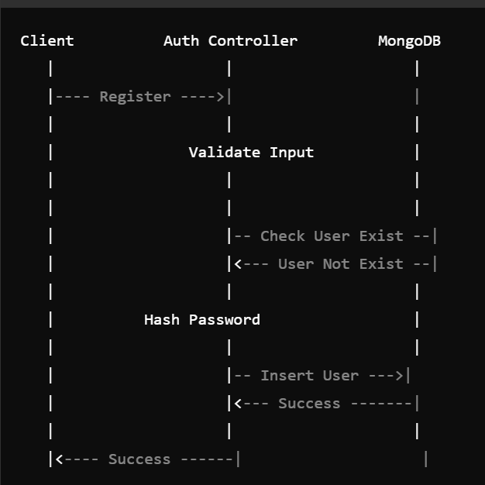

**### **4.2. Chat Workflow\*\***

**Flow Steps:**

1. **Joining a Chat Room:**

- Authenticated user selects or creates a chat room.

- Frontend emits a `join chat` event via Socket.io with room details.

- Backend listens for `join chat` and adds the user to the specified room.

- Backend broadcasts to the room that a new user has joined.

2. **Sending Messages:**

- User types a message and submits.

- Frontend emits a `new message` event with the message content and room ID.

- Backend receives the message, saves it to MongoDB, and broadcasts it to all users in the room via Socket.io.

3. **Receiving Messages:**

- Frontend listens for `message recieved` events.

- Upon receiving a message, the frontend updates the chat interface in real-time.

**\*\*Chat Flow Diagram:\*\***

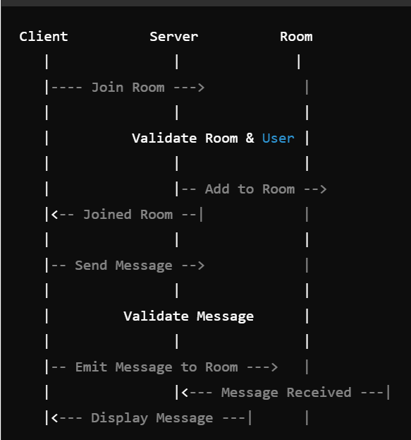

**### **4.3. Profile Management Workflow\*\***

**Flow Steps:**

1. **Viewing Profile:**

- User navigates to the profile section.

- Frontend fetches user details from the backend using the stored JWT for authentication.

---

**## **5. Database Schema\*\***

### **5.1. User Collection**

**Schema Definition:**

```javascript

const mongoose = require("mongoose");

const bcrypt = require("bcryptjs");

const userSchema = mongoose.Schema(

  {

    name: { type: "String", required: true },

    email: { type: "String", unique: true, required: true },

    password: { type: "String", required: true },

    pic: {

      type: "String",

      required: true,

      default:

        "https://icon-library.com/images/anonymous-avatar-icon/anonymous-avatar-icon-25.jpg",

    },

    isAdmin: {

      type: Boolean,

      required: true,

      default: false,

    },

  },

  { timestaps: true }

);

module.exports = mongoose.model('User', userSchema);

```

### **5.2. Chat Collection**

**Schema Definition:**

```javascript

const mongoose = require("mongoose");

const chatModel = mongoose.Schema(

  {

    chatName: { type: String, trim: true },

    isGroupChat: { type: Boolean, default: false },

    users: [{ type: mongoose.Schema.Types.ObjectId, ref: "User" }],

    latestMessage: {

      type: mongoose.Schema.Types.ObjectId,

      ref: "Message",

    },

    groupAdmin: { type: mongoose.Schema.Types.ObjectId, ref: "User" },

  },

  { timestamps: true }

);

```

---

**## **6. API Design\*\***

### **6.1. Authentication APIs**

| **Endpoint** | **Method** | **Description** | **Request Body** | **Response** |

|---------------------|------------|--------------------------------|------------------------------------------|------------------------------------|

| `/api/user `| `POST` | Register a new user | `{ name, email, password,image }` | `{ token, user }` |

| `/api/user/login` | `POST` | Authenticate user and login | `{ email, password }` | `{ token, user }` |

### **6.2. Chat APIs**

| **Endpoint** | **Method** | **Description** | **Request Body** | **Response** |

|-----------------------|------------|---------------------------------|--------------------------------|------------------------|

| `/api/chat` | `GET` | Retrieve all chat rooms | Headers: `Authorization: Bearer <token>` | `{ chats }` |

| `/api/chat/:chatId` | `GET` | Retrieve messages in a room | Headers: `Authorization: Bearer <token>` | `{ messages }` |

| `/api/chat` | `POST` | Create a new chat room | `{ room }` | `{ chat }` |

### **6.3. User Profile APIs**

| **Endpoint** | **Method** | **Description** | **Request Body** | **Response** |

|-----------------------------|------------|---------------------------------|----------------------------|------------------------|

| `/api/users/profile` | `GET` | Get user profile | Headers: `Authorization: Bearer <token>` | `{ user }` |

---

**## **7. Real-Time Communication\*\***

### **7.1. Event Flow Diagram**

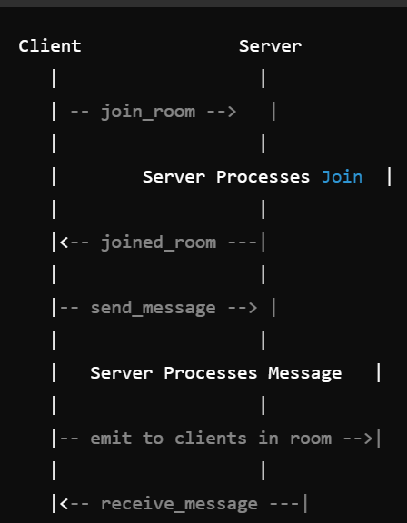

**Description of the Diagram:**

1. **Client A** connects to the server via Socket.io.

2. **Client A** emits a `join_room` event with the room name.

3. **Server** adds **Client A** to the specified room and emits a `user_joined` event to all clients in the room.

4. **Client B** in the same room receives the `user_joined` event.

5. **Client A** sends a message by emitting a `send_message` event.

6. **Server** receives the message and broadcasts a `receive_message` event to all clients in the room, including **Client A** and **Client B**.

7. Both clients display the new message in their chat interfaces.

---

**## **8. Security Considerations\*\***

### **8.1. Authentication and Authorization**

- **JWT Tokens**: Securely generate and verify JWT tokens for user authentication. Tokens should be stored securely on the client-side (e.g., HTTP-only cookies or secure storage).

- **Protected Routes**: Implement middleware on the backend to protect sensitive API routes, ensuring only authenticated users can access them.

### **8.2. Password Security**

- **Hashing**: Use `bcryptjs` to hash user passwords before storing them in the database.

- **Salting**: Implement salting to enhance password security against rainbow table attacks.

### **8.3. Data Validation**

- **Input Sanitization**: Validate and sanitize all user inputs to prevent injection attacks.

- **Schema Validation**: Use Mongoose schemas to enforce data integrity.

### **8.4. Secure Communication**

- **HTTPS**: Deploy the application over HTTPS to encrypt data in transit.

- **CORS**: Configure CORS policies to restrict resource access to trusted origins.

### **8.5. Rate Limiting and Throttling**

- **Prevent Brute Force Attacks**: Implement rate limiting on authentication endpoints to mitigate brute force attempts.

- **Socket.io Rate Limiting**: Limit the number of messages a user can send within a specific timeframe to prevent spam.

### **8.6. Environment Variables**

- **Sensitive Data**: Store sensitive information like JWT secret keys, database URIs, and API keys in environment variables using `dotenv`.

- **Configuration Management**: Ensure environment variables are not exposed in the client-side code.

---

**## **9. Scalability and Performance\*\***

### **9.1. Horizontal Scaling**

- **Load Balancing**: Use load balancers to distribute incoming traffic across multiple server instances.

- **Stateless Servers**: Ensure servers are stateless by storing session information in JWTs and databases, facilitating horizontal scaling.

### **9.2. Database Optimization**

- **Indexing**: Implement indexes on frequently queried fields (e.g., email in the User collection) to speed up database operations.

- **Sharding**: For large-scale deployments, consider sharding the MongoDB database to distribute data across multiple machines.

### **9.3. Caching**

- **Redis**: Integrate Redis for caching frequently accessed data, reducing database load and improving response times.

### **9.4. Real-Time Communication Optimization**

- **Socket.io Rooms**: Utilize Socket.io rooms to efficiently manage real-time communication within specific chat rooms.

- **Message Batching**: Implement message batching to handle high-frequency message flows without overwhelming the server.

### **9.5. Frontend Performance**

- **Code Splitting**: Use code splitting and lazy loading in React to reduce initial load times.

- **Optimized Assets**: Compress images and optimize assets to enhance frontend performance.

### **9.6. Monitoring and Logging**

- **Monitoring Tools**: Implement monitoring tools like **PM2**, **New Relic**, or **Datadog** to track application performance and uptime.

- **Logging**: Use structured logging with tools like **Winston** or **Morgan** to capture and analyze logs for troubleshooting.

---

**## **10. User Interface Design\*\***

### **10.1. UI Components**

- **Authentication Pages**:

- **Login**: Form with email and password fields.

- **Register**: Form with name, email, and password fields.

- **Chat Interface**:

- **Chat Rooms List**: Sidebar displaying available users to search for chatting.

- **Chat Window**: Main area displaying messages and input field.

- **Profile Page**:

- **User Information**: Display and edit user details.

- **Profile Picture**: Upload and display profile images.

- **Navigation Bar**:

- **Links**: Home, Profile, Logout.

- **Notifications**: Real-time notifications for new messages or users joining.

### **10.2. UI Flow Diagram**

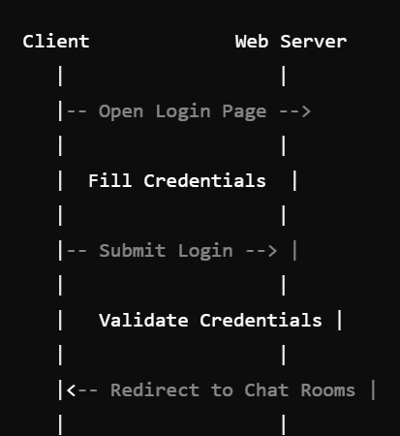

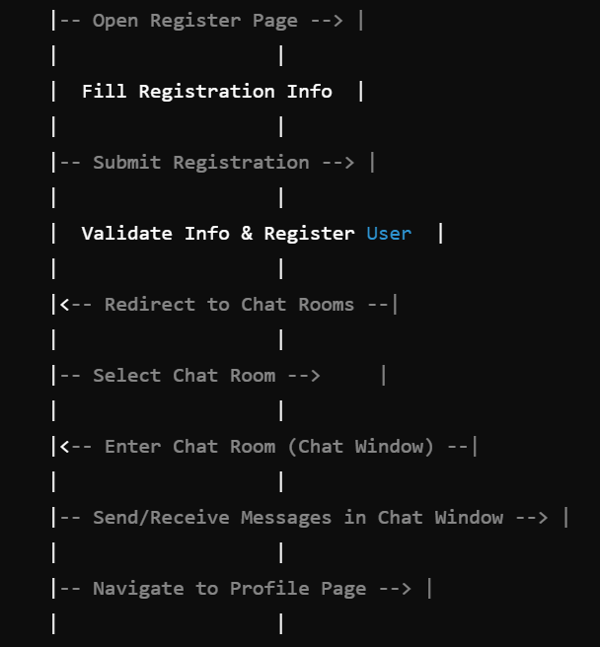

**Description of the Diagram:**

1. **User Accesses Application**:

- If not authenticated, redirected to the **Login** page.

- Option to navigate to the **Register** page.

2. **After Authentication**:

- Redirected to the **Chat Rooms List**.

- Can select a user after searching users to enter the **Chat Window**.

3. **Profile Management**:

- Accessible via the **Navigation Bar**.

- Allows viewing and editing of user profile.

4. **Real-Time Updates**:

- **Chat Window** updates messages in real-time.

- **Navigation Bar** displays notifications for new activities.

---

## **11. Conclusion**

The **BuzzLine Application** built with the MERN stack provides a robust platform for users to communicate seamlessly in real-time. By leveraging technologies like **Socket.io** for instant messaging, **JWT** for secure authentication, and **Chakra UI** for an intuitive interface, the application ensures both functionality and user experience. The system design emphasizes scalability, security, and performance, making it well-suited for handling a growing user base and high message throughput. Proper deployment strategies and continuous monitoring further ensure the application's reliability and maintainability.

---

## **Appendix**

### **A. Glossary**

- **MERN Stack**: A combination of MongoDB, Express.js, React.js, and Node.js used for full-stack web development.

- **Socket.io**: A JavaScript library for real-time web applications.

- **JWT (JSON Web Token)**: A compact, URL-safe means of representing claims to be transferred between two parties.

- **Chakra UI**: A simple, modular, and accessible component library that gives you the building blocks to build React applications.

- **CORS (Cross-Origin Resource Sharing)**: A mechanism to allow or restrict requested resources on a web server depending on where the HTTP request was initiated.

### **B. References**

- [MERN Stack Tutorial](https://www.mongodb.com/mern-stack)

- [Socket.io Documentation](https://socket.io/docs/v4/)

- [Chakra UI Documentation](https://chakra-ui.com/docs/getting-started)

- [Express.js Documentation](https://expressjs.com/)

- [React.js Documentation](https://reactjs.org/docs/getting-started.html)

- [MongoDB Mongoose Documentation](https://mongoosejs.com/docs/guide.html)

---

*This document provides a comprehensive overview of the system design for a real-time chat application using the MERN stack. For detailed implementation guides, refer to the respective sections and external resources mentioned in the references.*

**\*\*Finally I am attaching an image to view my workflow of the application:::**

**Link::** [**https://whimsical.com/buzzline-Urud7vtvxqs96C6NJqJhH2**](https://whimsical.com/buzzline-Urud7vtvxqs96C6NJqJhH2)

